**Practical No. 10**

**Template**

**Program 10(a):** Write a program to generic function or template and demonstrate swapping of multiple types of data using the same.

**Coding:**

#include<iostream.h>

#include<conio.h>

template <class x>x add(x a,x b)

{

return(a+b);

}

void main()

{

clrscr();

cout<<add(3,5)<<endl;

cout<<add(3.5,6.2)<<endl;

cout<<add(2.0,4.5)<<endl;

getch();

}

**Output:**

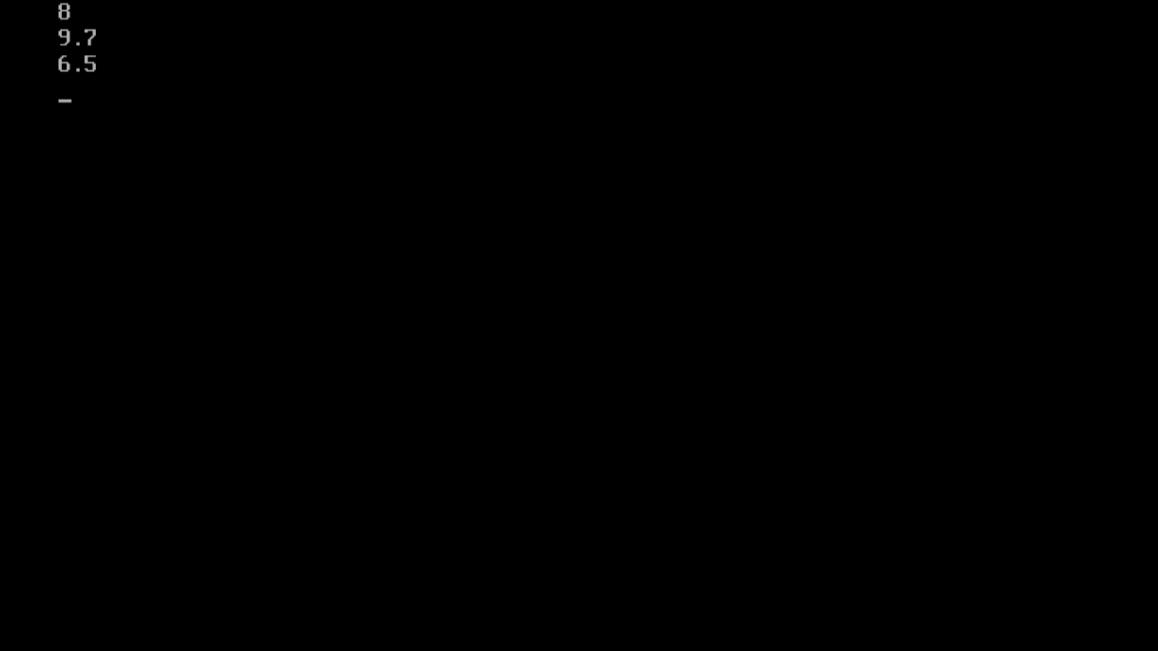

**Program 10(b):** Write a program to generic function or template and demonstrate swapping of multiple types of data using the same. By showing the implementation of template class library for swap function.

**Coding:**

#include<iostream.h>

#include<conio.h>

template <class x>void swap(x &a,x &b)

{

x temp;

temp=a;

a=b;

b=temp;

}

void main()

{

clrscr();

int a=4,b=5;

float p=3.5,q=4.2;

cout<<"a="<<a<<"\tb="<<b<<" before calling swap function"<<endl;

swap(a,b);

cout<<"a="<<a<<"\tb="<<b<<" after calling swap function"<<endl;

cout<<"p="<<p<<"\tq="<<q<<" before calling swap function"<<endl;

swap(p,q);

cout<<"p="<<p<<"\tq="<<q<<" after calling swap function"<<endl;

getch();

}

**Output:**

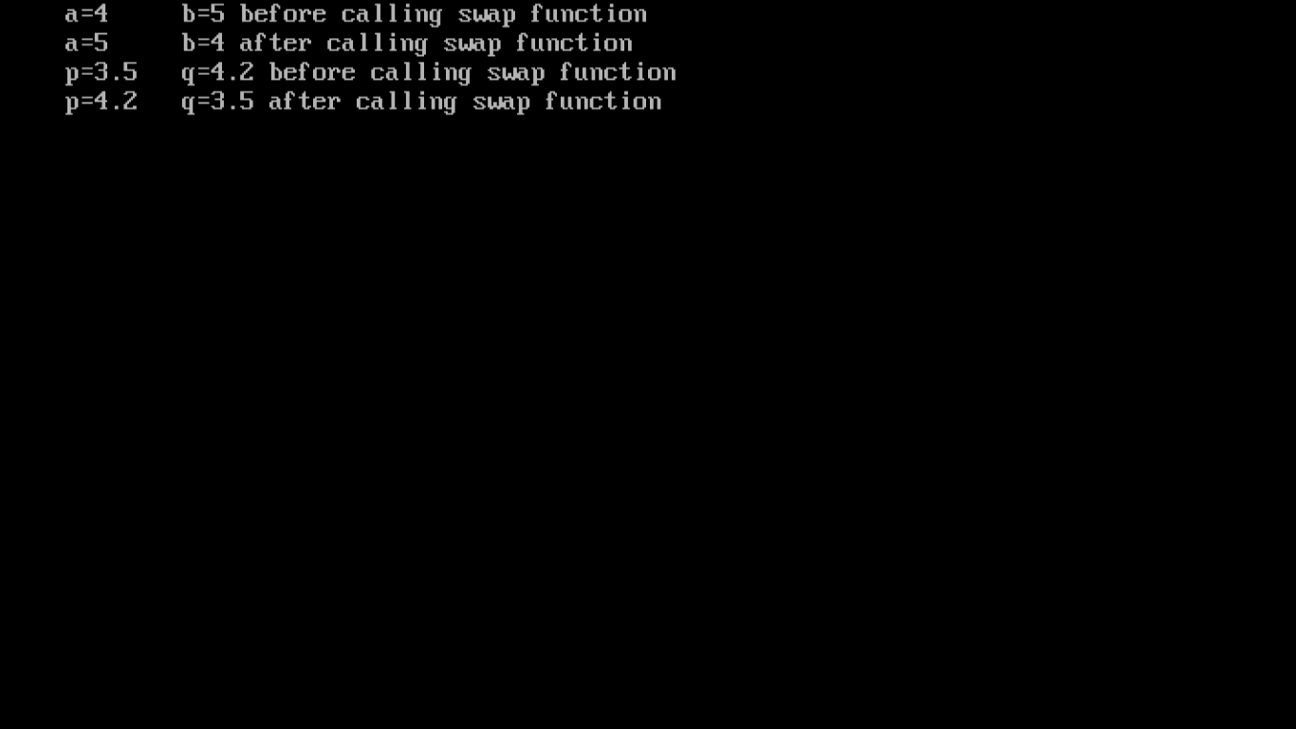

**Program 10(c):** Design the template class library for sorting ascending to descending and vice versa.

**Example:** Write a C++ program using a class template to read any parameterized data type such as float and integer and print them in sorted form.

**Coding:**

#include<iostream.h>

#include<conio.h>

template <class x>void sort(x a[],int n)

{

int i,j;

x temp;

for(i=0;i<=n-2;i++)

{

for(j=0;j<=n-2;j++)

{

if(a[j]>a[j+1])

{

temp=a[j];

a[j]=a[j+1];

a[j+1]=temp;

}

}

}

}

void main()

{

clrscr();

int a[100],m,n,i;

float b[100];

cout<<"Enter number of integers:";

cin>>n;

for(i=0;i<=n-1;i++)

{

cout<<"Enter an integer :";

cin>>a[i];

}

sort(a,n);

cout<<"Sorted array:\n";

for(i=0;i<=n-1;i++)

{

cout<<a[i]<<"\t";

}

cout<<endl;

cout<<"Enter number of float numbers:";

cin>>m;

for(i=0;i<=m-1;i++)

{

cout<<"Enter a float number:";

cin>>b[i];

}

sort(b,m);

cout<<"Sorted array:\n";

for(i=0;i<=m-1;i++)

{

cout<<b[i]<<"\t";

}

cout<<endl;

getch();

}

**Output:**

